**ABSTRACT**

This paper is scrutinizes the use of different concepts of applets in Software Engineering, enabling viewer to get the complete concept of different aspects of Software Engineering. Software is a collection of instructions and data that tell a computer how to work. This is in contrast to physical hardware, from which the system is built and actually performs the work. To satisfy this we created a simple program for Blog Management System.

**INDEX**

|  |  |  |
| --- | --- | --- |
| **Sr. No.** | **Contents** | **Page No.** |
| 1. | Introduction | 3 |
| 2. | Code | 6 |
| 3. | Result | 10 |
| 4. | Conclusion | 14 |
| 5. | Reference | 15 |

**Chapter-1**

**INTRODUCTION**

**Software:**

Software is a collection of instructions and data that tell a computer how to work. This is in contrast to physical hardware, from which the system is built and actually performs the work. In computer science and software engineering, computer software is all information processed by computer systems, including programs and data. Computer software includes computer programs, libraries and related non-executable data, such as online documentation or digital media. Computer hardware and software require each other and neither can be realistically used on its own.



Fig.1. Software

**Software Engineering:**

Software engineering is a branch of computer science which includes the development and building of computer systems software and applications software. Computer systems software is composed of programs that include computing utilities and operations systems. Applications software consists of user-focused programs that include web browsers, database programs, etc.

Software engineers have extensive knowledge of programming languages, software development, and computer operating systems, and they apply engineering principles to software creation. By applying these engineering principles to every stage of the development process, from requirements analysis to the software process, they can create customized systems for individual clients. Just as a civil engineer will make sure that a bridge has a solid foundation, a software engineer will also begin with a thorough study of requirements and work through the development process in a systematic way.



Fig.2 .Software Engineering

**Blog:**

Blog (a truncation of "weblog")[1] is a discussion or informational website published on the World Wide Web consisting of discrete, often informal diary-style text entries (posts). Posts are typically displayed in reverse chronological order, so that the most recent post appears first, at the top of the web page. Until 2009, blogs were usually the work of a single individual,[citation needed] occasionally of a small group, and often covered a single subject or topic. In the 2010s, "multi-author blogs" (MABs) emerged, featuring the writing of multiple authors and sometimes professionally edited. MABs from newspapers, other media outlets, universities, think tanks, advocacy groups, and similar institutions account for an increasing quantity of blog traffic. The rise of Twitter and other "microblogging" systems helps integrate MABs and single-author blogs into the news media. Blog can also be used as a verb, meaning to maintain or add content to a blog.

On February 16, 2011, there were over 156 million public blogs in existence. On February 20, 2014, there were around 172 million Tumblr[4] and 75.8 million WordPress[5] blogs in existence worldwide. According to critics and other bloggers, Blogger is the most popular blogging service used today. However, Blogger does not offer public statistics.[6][7] Technorati lists 1.3 million blogs as of February 22, 2014.[8]

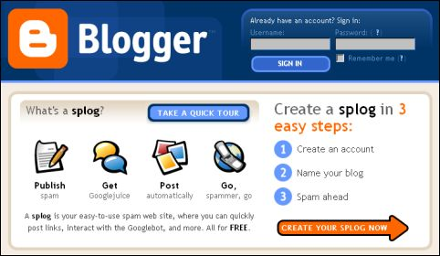

Fig.3. BlogSpot

**Chapter-2**

**CODE**

**‘ Login.vb**

**Public Class Login**

**Private Sub Form1_Load(sender As Object, e As EventArgs) Handles MyBase.Load**

**End Sub**

**Private Sub Label1_Click(sender As Object, e As EventArgs) Handles Label1.Click**

**Label1.TextAlign = ContentAlignment.MiddleCenter**

**End Sub**

**Private Sub Button1_Click(sender As Object, e As EventArgs) Handles Button1.Click**

**If TextBox1.Text = "Omkar" And**

**TextBox2.Text = "OMKAR123" Then**

**MsgBox("Welcome to Blog", MsgBoxStyle.ApplicationModal, "Blog")**

**Main.Show()**

**Visible = False**

**Else**

**MsgBox("Wrong Username or Password!", MsgBoxStyle.Exclamation, "Blog")**

**End If**

**End Sub**

**Private Sub Button2_Click(sender As Object, e As EventArgs) Handles Button2.Click**

**End**

**End Sub**

**End Class**

**‘ Main.vb**

Public Class Main

Private Sub Main_Load(sender As Object, e As EventArgs) Handles MyBase.Load

IsMdiContainer = True

Me.Text = "Welcome"

End Sub

Private Sub RoomToolStripMenuItem_Click(sender As Object, e As EventArgs) Handles RoomToolStripMenuItem.Click

Dim fm2 As New CreateBlog

fm2.MdiParent = Me

fm2.Show()

End Sub

Private Sub OtherServicesToolStripMenuItem1_Click(sender As Object, e As EventArgs) Handles OtherServicesToolStripMenuItem1.Click

Dim fm3 As New Blogstatus

fm3.MdiParent = Me

fm3.Show()

End Sub

Private Sub CancelRoomToolStripMenuItem1_Click(sender As Object, e As EventArgs) Handles CancelRoomToolStripMenuItem1.Click

Dim fm4 As New OtherServices

fm4.MdiParent = Me

fm4.Show()

End Sub

Private Sub ContactUsToolStripMenuItem1_Click(sender As Object, e As EventArgs) Handles ContactUsToolStripMenuItem1.Click

Dim fm5 As New DeleteBlog

fm5.MdiParent = Me

fm5.Show()

End Sub

Private Sub ContactUsToolStripMenuItem_Click(sender As Object, e As EventArgs) Handles ContactUsToolStripMenuItem.Click

Dim fm6 As New ContactUs

fm6.MdiParent = Me

fm6.Show()

End Sub

End Class

**‘ createblog.vb**

Public Class CreateBlog

Private Sub Form2_Load(sender As Object, e As EventArgs) Handles MyBase.Load

End Sub

Private Sub Button2_Click(sender As Object, e As EventArgs) Handles Button2.Click

Close()

End Sub

Private Sub Save_Click(sender As Object, e As EventArgs) Handles Save.Click

If CheckBox1.Checked = True Then

MsgBox("Data Saved!, your Blog ID is 69", MsgBoxStyle.Information, "Blog")

Close()

Else

MsgBox("Please Check the Agree Terms and Condition Box", MsgBoxStyle.Information, "Blog")

End If

End Sub

End Class

**‘ deleteblog.vb**

Public Class DeleteBlog

Private Sub Button1_Click(sender As Object, e As EventArgs) Handles Button1.Click

MsgBox("Your Room has been successfully Canceled", MsgBoxStyle.Information, " Nourriture pour le plaisir")

Visible = False

End Sub

End Class

**‘otherservices.vb**

Public Class OtherServices

Private Sub OtherServices_Load(sender As Object, e As EventArgs) Handles MyBase.Load

End Sub

Private Sub Button1_Click(sender As Object, e As EventArgs) Handles Button1.Click

MsgBox("Data Saved", MsgBoxStyle.Information, "Blog")

Visible = False

End Sub

Private Sub Button2_Click(sender As Object, e As EventArgs) Handles Button2.Click

Close()

End Sub

End Class

**‘ contactus.vb**

Public Class ContactUs

Private Sub Button1_Click(sender As Object, e As EventArgs) Handles Button1.Click

MsgBox("Sent!", MsgBoxStyle.Information, " Nourriture pour le plaisir")

Visible = False

End Sub

End Class

**‘blogstatus.vb**

Public Class Blogstatus

Private Sub Roomstatus_Load(sender As Object, e As EventArgs) Handles MyBase.Load

End Sub

Private Sub Label3_Click(sender As Object, e As EventArgs) Handles Label3.Click

End Sub

End Class

**Chapter-3**

**RESULT**

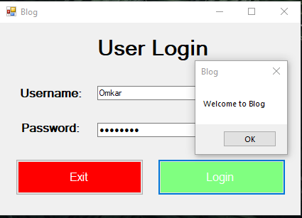

Fig. 4. User Login

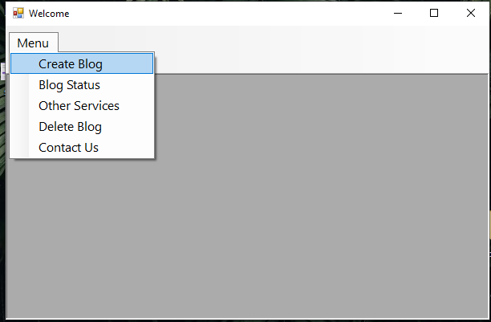

Fig. 5. Menu

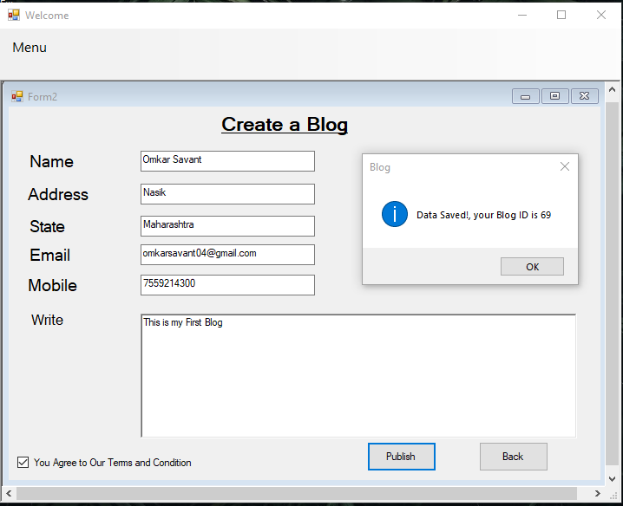

Fig. 6. Create Blog

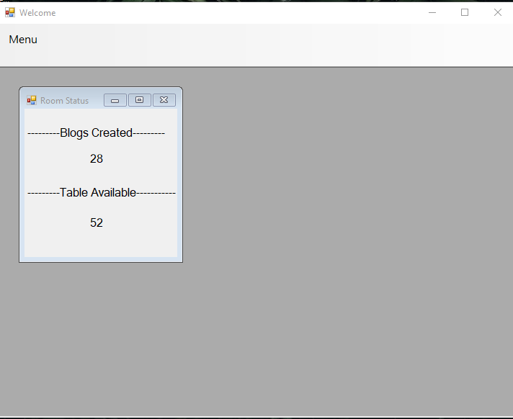

Fig. 7. Blog Status

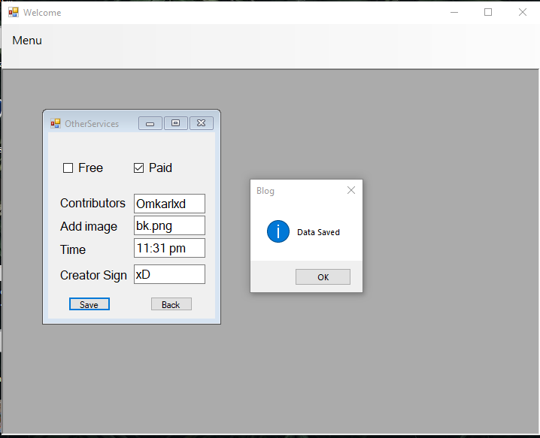

Fig. 8. Other Services

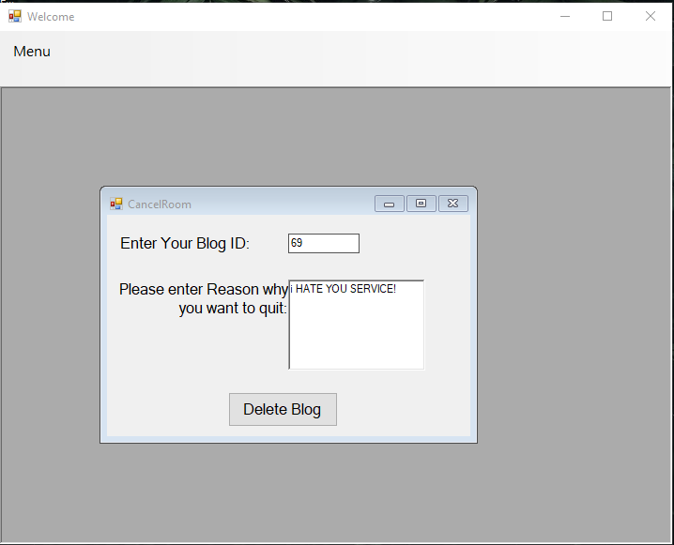

Fig. 9. Delete Blog

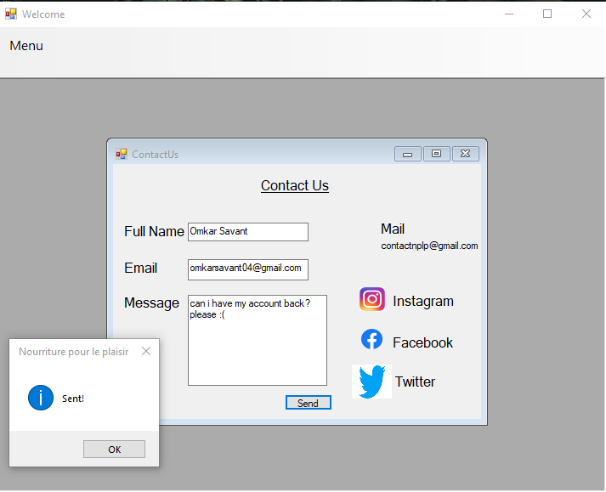

Fig. 10. Contact Us

**CONCLUSION**

Software engineering is the systematic application of engineering approaches to the development of software. There is a lot of investment going into software engineering at the moment due to the increasing reliance on mobile technology, venture capital-backed start-ups, the growing complexity of technology, and emerging industries. The demand for skilled and qualified software engineers seems to have no end. This demand is strengthened by a changing economic landscape and fueled by the need for technology solutions. With billions of physical devices around the world that are now connected to the internet and that are collecting and sharing data, all industries are quickly becoming technology driven industries. Software engineers have extensive knowledge of programming languages, software development, and computer operating systems, and they apply engineering principles to software creation. By applying these engineering principles to every stage of the development process, from requirements analysis to the software process, they can create customized systems for individual clients. Just as a civil engineer will make sure that a bridge has a solid foundation, a software engineer will also begin with a thorough study of requirements and work through the development process in a systematic way.

**REFERENCES**

1. <https://www.careerexplorer.com/careers/software-engineer/>
2. <https://en.wikipedia.org/wiki/Software_engineering>
3. <https://en.wikipedia.org/wiki/Software>